**PROJECT DOCUMENTATION**

**FitFlex: Your Personal Fitness Companion**

**1.Introduction**

* **Project Title**: FitFlex: Your personal Fitness Companion
* **Team ID:** NM2025TMID47870
* **Team Size:** 4
* **Team Leader:**

DEEPAK SINGH S([sdeepaksingh3005@gmail.com](mailto:sdeepaksingh3005@gmail.com))

* **Team Members:**

BOOMI BALAGAN V([boomibalagan6536@gmail.com](mailto:boomibalagan6536@gmail.com))

GOKULA KRISHNAN J([gokulajkp885@gmail.com](mailto:gokulajkp885@gmail.com))

KAVI S([kaviselvarajmbbs@gmail.com](mailto:kaviselvarajmbbs@gmail.com))

**2. Project Overview and Background**

* FitFlex: Your Personal Fitness Companion is a digital solution designed to assist individuals in
* maintaining their physical health and fitness goals through personalized tracking, guidance, and motivation.
* In today’s busy lifestyle, many struggle to balance work, diet, and exercise routines. FitFlex bridges this
* gap by providing a user-friendly platform to monitor fitness progress, set achievable goals, and receive ● real-time insights.
* The project integrates modern technologies and intuitive interfaces to encourage consistent exercise,
* heating habits, and overall wellness management. It caters to people of all ages looking for a
* smart and reliable fitness companion.
* This backend supports a fitness companion app focused on personalized workout plans, exercise tracking,
* and progress monitoring. It aims to help users achieve fitness goals through custom plans and user data management.

**3.Project Objectives**

* To develop a personalized fitness companion application that encourages users to maintain regular ● fitness habits.
* To provide diet and workout tracking features tailored to individual needs.
* To enhance user motivation through progress tracking and performance insights.
* To design an easy-to-use platform accessible on multiple devices.
* To incorporate a data-driven approach for recommending workouts and dietary plans

**4. Architecture & Tech Stack**

* **Backend Framework:** Node.js (commonly used for scalability and performance in such projects)
* **Database:** MongoDB or a similar NoSQL database for flexible storage of workout data, user profiles, and progress
* **API:** RESTful APIs to enable communication between frontend (app) and backend services for data exchange and user authentication
* **Authentication:** JWT (JSON Web Tokens) for secure user login and session management

**5. project demo**

Before starting to work on this project, let’s see the demo.

Demo link:

<https://drive.google.com/file/d/1xbzVoqxeJRnvsh0FWv5D16EOANfwZ8U8/view>?usp=sharing

Use the code

in: [https://drive.google.com/drive/folders/14f9eBQ5W7VrLdPhP2W6PzOU_HCy8UMex](https://drive.google.com/drive/folders/14f9eBQ5W7VrLdPhP2W6PzOU_HCy8UMex%20) [?usp=sharing](https://drive.google.com/drive/folders/14f9eBQ5W7VrLdPhP2W6PzOU_HCy8UMex?usp=sharing)

**Folder Structure (Example)**

text

/src

/controllers # Handle HTTP requests

/models # Database schema definitions

/routes # API route definitions

/middlewares # Authentication, logging, error handling

/utils # Helper functions and constants /config.js # Environment configurations server.js # Entry point to start the server

API Documentation (Sample Endpoints)

POST /api/auth/register - User registration

POST /api/auth/login - User login and token issue

GET /api/workouts - Retrieve all workouts

POST /api/workouts - Create a new workout plan

GET /api/progress/:userId - Get user's progress data

Testing

Use Jest or Mocha for backend unit and integration testing

Test API endpoints using tools like Postman or automated test scripts

**7. Roles and Responsibilities of Team Members**

1. **Deepak Singh S (Team Leader):**

Oversees project progress, manages task allocation, ensures timely completion, and coordinates between team members. Leads the development direction and supervises documentation.

1. **Boomi Balagan V (Team Member):**

Responsible for front-end development, designing user interfaces, and ensuring visual appeal and usability of the application.

1. **Gokula Krishnan J (Team Member):**

Works on back-end development, database management, and server-side integration ensuring seamless connectivity between modules.

1. **Kavi S (Team Member):**

Takes charge of research, testing, and quality assurance. Validates the functionality of features and ensures the application meets user expectations.

**8. Work Distribution among Team Members**

**Deepak Singh S:** Project management, core module development, final integration.

**Boomi Balagan V:** UI/UX designing, mobile app interface creation.

**Gokula Krishnan J:** Server-side scripting, back-end database and API development.

**Kavi S:** Application testing, bug fixing, and research documentation.

**9. Project Timeline and Milestones**

* Week 1-2: Project planning, requirement gathering, and initial research.
* Week 3-4: Design of user interface and system architecture.
* week 5-6: Development of core features (workout and diet tracking).
* Week 7: Integration of front-end and back-end systems.
* week 8: Testing and debugging.
* Week 9: Final review, user feedback, and optimization.
* Week 10: Submission of final deliverables and demonstration.

**10. Expected Results and Deliverables**

* A fully functional fitness companion application that supports workout and diet tracking.
* Project documentation including system design, testing reports, and user manuals.
* A video demonstration showcasing key features of the application.
* Deployment-ready software package with instructions for installation and usage.

**11. Communication and Collaboration Plan**

* Weekly Team Meetings: To track progress and resolve challenges.
* Communication Channels: WhatsApp group for quick updates, Google Meet/Zoom for virtual discussions.
* Collaboration Tools: GitHub for code management, Google Drive for documentation sharing, Trello for task tracking.
* Progress Reporting: Weekly task reports to monitor deadlines and responsibilities.

**12. Screenshots or Demo**

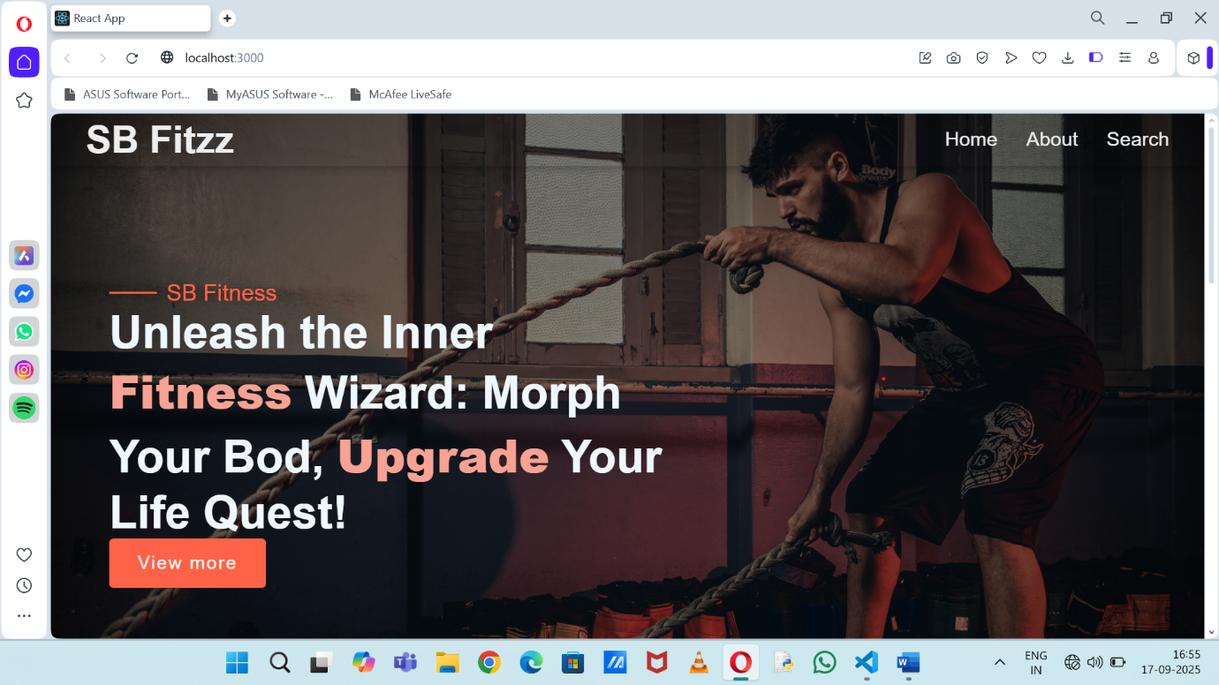

**13. Conclusion**

* FitFlex is designed to be a comprehensive personal fitness companion that enhances motivation, improves health
* outcomes, and provides an engaging user experience. With efficient teamwork, clear objectives, and structured timelines,
* the project aims to deliver a high-quality solution that helps users incorporate fitness seamlessly into their daily routine.
* Test API endpoints using tools like Postman or automated test scripts